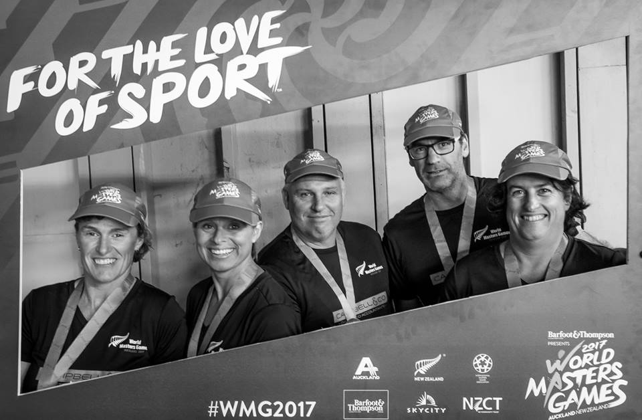 |  | Badminton Canterbury  - May Newsletter

Recent News

World Masters Results
The World Masters Games came to an end last week. Our Canterbury Masters contingent did us proud with some amazing results:
PAM BOURKE-SHAW- Gold, Women’s 70+
TREVOR CAMPBELL- Gold Men’s Singles 50+, Silver Men’s Doubles 45+, Bronze Mixed Teams Event 45+
ALFRED WONG- Gold 40+ teams event A Grade, Silver Men’s Singles 40+ A grade
PAM GEARD – Gold Women’s Doubles 55+, Silver Mixed Teams Event 50+
FIONA PIZZEY – Bronze Women’s Singles 50+
JEANNA RILEY - Gold Women’s Singles 45+, Bronze Mixed Team Event 45+
ANNA RITCHIE- Bronze Women’s Doubles 35+, Bronze Women’s Singles 35+
CHRISTINA ROBB- Bronze Mixed Teams Event 35+
ANGELA SAMSON – Bronze Mixed Teams Event 35+
STEVE TAPP – Bronze Men’s Doubles 45+, Bronze Mixed teams event 45+
SHANE MICHAEL- Bronze Men’s Doubles 45+, Bronze Mixed teams event 45+
South Island Junior Teams Event Results
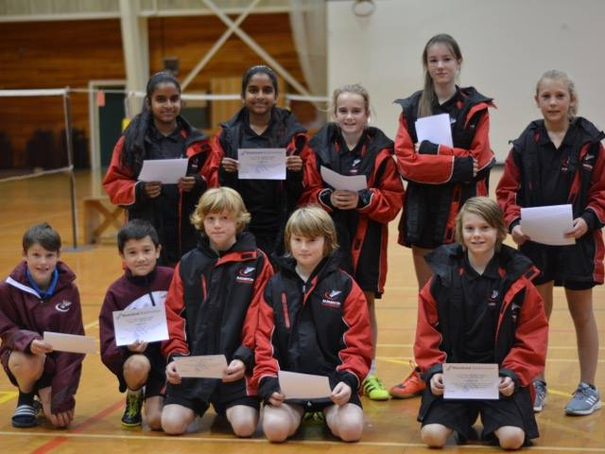
Canterbury Junior representatives had a great time together in Timaru at the South Island junior teams event. They had fantastic results at all age levels:
UNDER 13 – 1st Canterbury Red,2nd Canterbury Black
Under 15 – 1st Canterbury
Under 17s – 1st Canterbury
Under 19s – 2nd Canterbury

COMING UP
COACHING COURSE
Shuttle Time Coaching course
Saturday 3rd June. 10am -4pm.
Become a qualified Shuttle Time Coach. Shuttle Time is a great introduction to coaching badminton. This would suit teachers, coaches in clubs or anyone interested in coaching beginners. There is no cost for this course. Please contact Julie : office@badmintoncanterbury.com to register. Please include your contact details in your email.
COMPETITIONS
CANTERBURY OPEN - 30th of June and the 1st of July.
CANTERBURY UNDER 19/ 15s OPEN- 19th/20th August.

