Badminton Canterbury
  - March Newsletter

Recent News

Cameras
You may be aware that security cameras have now been installed inside the badminton hall and also outside overlooking the main car park and Softball lane. Hopefully this will help prevent the car break-ins which have been a somewhat regular occurrence for many frustrated badminton players.
Emergency Exit Alarms and Court Damage
All emergency exits are now alarmed. These exits are only to be used in the case of an emergency.
Please ensure that you wear the correct footwear on court - non-marking court shoes. There have been a series of dark marks left on courts due to players wearing the incorrect footwear which are very difficult to remove. No shoes with heels on the courts at any time.
Please also note that card owners are responsible for any damage or charges made by people using the courts that they have booked. If you notice someone behaving in a way that may be causing damage to the facility please email the office advising them of the court number and time that it happened.
Canterbury Senior teams
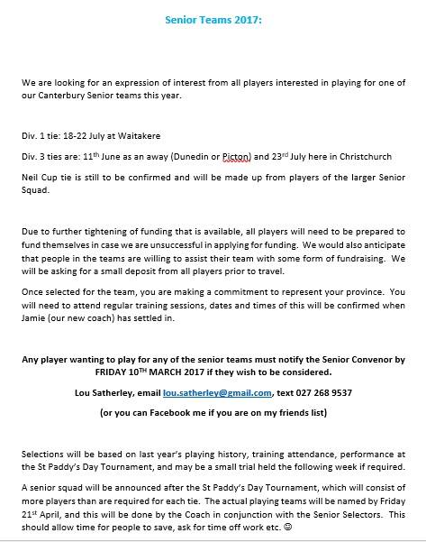
If you are wanting to play for a Canterbury Senior team this year please email the office with your full name, contact and which team you wish to be considered for.
New Masters Convenor
We welcome Doug Edginton as our Masters Convenor. Doug will be taking over from the wonderful Christine Wallace. We would like to thank Christine for the superb job she did as Masters Convenor and wish her all the best in sunny Nelson.

COMING UP
AGM
The Badminton Canterbury AGM will be held upstairs at Badminton Hall on Wednesday 12th of April.
COMPETITIONS
St Paddy’s Day Tournament
For those of you that have not already done so, don’t forget to register for the St Patrick’s Day tournament. Entries close at midnight 12th of March. Jamie Neill, our new high performance coach will be playing, so it will be a great opportunity for our players to watch him play and get to know him.
http://www.tournamentsoftware.com/sport/tournament.aspx?id=40815CDC-6676-4CC6-A389-3DA10CB10C95
World Masters Games
The World Masters Games are being held in Auckland in April 2017. Canterbury Badminton has over 35 players entering what is sure to be an amazing event. The World Masters Games is a 10 day event with over 25, 000 athletes and 28 sports.
South Island Junior Teams Event
This year the South Island Junior teams event will be held in Timaru from the 27th-29th of April. It will be somewhat different from previous years as Under 13s, Under 15s, Under 17s and Under 19s will all be playing at the same venue on the same dates.

Under 23’s Competition
Canterbury Badminton will be hosting an Under 23’s teams completion between Canterbury, Otago and Sourhland. This will be held on the 22nd and 23rd of April. If you are interested in playing please email the office: office@badmintoncanterbury.com

