Badminton Canterbury
  - December Newsletter

Recent News

New Coach
Badminton Canterbury are extremely excited to announce that Jamie Neill has been appointed as our new high performance coach. Jamie is from Scotland and has represented Scotland internationally. He has extensive coaching experience at all levels. Jamie will be starting in February 2017.

Junior pre-Christmas fun evening
Junior players enjoyed a night of fun and games at the Badminton Canterbury pre-Christmas party. It was great to see some of our older more experienced juniors having fun with some of our newer players.
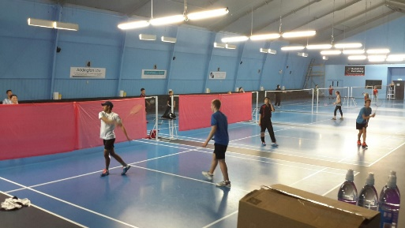
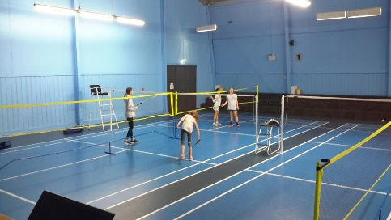
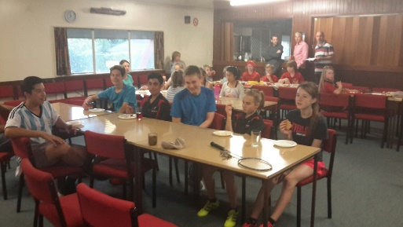
Wednesday Social Badminton
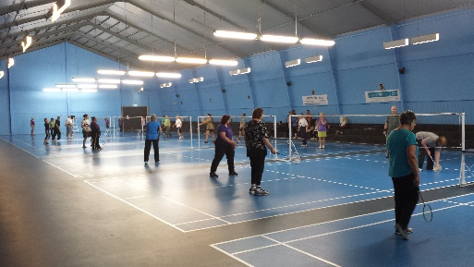
Wednesday social badminton is thriving and has continued to grow in 2016. There are several social groups that play at badminton hall on Wednesday mornings. Social badminton will resume in early 2017 so if you are free on a Wednesday and want to play a bit of social badminton come along. For more information about different social groups please contact Julie at the office: office@badmintoncanterbury.com
What’s on over the holidays?
Juniors:
Badminton Canterbury are running two different programmes over the school holidays:
Beginner Badminton Sessions
Two badminton sessions designed for beginners between 5-12 years old. Sessions will cover basic skills with a fun and friendly focus and will be run by Badminton Canterbury coach Megan Heaney. Limited number of spaces available. Players can register for either one or both session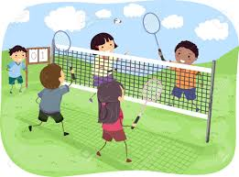
WHEN: January 19th and 20th. 1-3PM.
WHERE: Badminton Hall
COST: $15 for one session or $25 for both
If you would like to enquire or register for these sessions please contact: office@badmintoncanterbury.com

Christmas Holiday Badminton Coaching Clinic
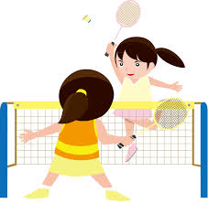

A comprehensive 3 day coaching clinic designed for junior players aged between 9-14 years old. This clinic is a development opportunity for children who have already mastered the basic skills of badminton and are wanting to improve their game. Sessions will focus on physical, tactical and technical aspects of badminton and will be run by Badminton Canterbury coach Megan Heaney. Limited number of spaces available.
WHEN: January 9th, 10th and 11th from 9 am – 3pm.
WHERE: Badminton Hall
COST: $100
If you would like to enquire or register for these sessions please contact: office@badmintoncanterbury.com

COMING UP
TRAINING
Seniors:
What: Training for all players who are intending to play Division 1 or Division 3.
When: Sundays. 2-4pm. 22ND January- 19th February.
Cost: $40 for four sessions. Payment is required in full before the first session. Please contact: office@badmintoncanterbury.co.nz if you would like to register for these sessions.
Masters:

What: World Masters training. Open to all Masters.
When: Sundays 4-6 pm. Beginning on 22nd January – 9th April.
Cost: $120 payment is required in full before the first session. Please contact: office@badmintoncanterbury.co.nz if you would like to register for these sessions.
COMPETITIONS
World Masters Games
The World Masters Games are being held in Auckland in April 2017. Canterbury Badminton has over 35 players entering what is sure to be an amazing event. The World Masters Games is a 10 day event with over 25, 000 athletes and 28 sports.
St Paddy’s Day Tournament
There will be no Anzac tournament in 2017. This will be replaced by a tournament which will be held on St Patrick’s Day instead. This is a great tournament for all players, particularly those entering the World Masters games and Division team members.
South Island Junior Teams Event
This year the South Island Junior teams event will be held in Timaru from the 27th-29th of April. It will be somewhat different from previous years as Under 13s, Under 15s, Under 17s and Under 19s will all be playing at the same venue on the same dates.

Badminton Canterbury would like to wish all players and their families a happy and safe Christmas and New Year.

